**Full Name:** 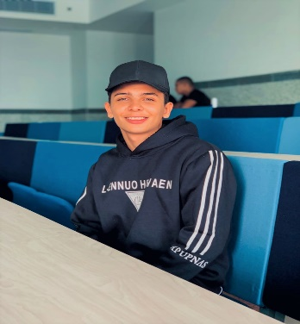

ALI REDA ALI MOHAMMED ALI RASHED

**Address:** 109 EL TAHRIR ST**.,** DOKKI -GIZA

**Phone No:** 01022283606

**E-mail:** reda01944@gmail.com

Education:

Faculty of Commerce**,** HNU

**Secondary Stage:** Orman Military SecondryFor BOYs

Work experiences:

Training of Faisal Islamic Bank

Courses:

English and German courses

Languages:

1-Arabic

2-Einglish

3-German